Project Exercise

**Code repository link:**

The entire code of this course is available on GitHub.

Link to the repo: <https://github.com/nitishwebgentle/asp-net-core-web-api>

To download the code in your system there are two ways:

**1. Clone Code using Git**

To download the code using Git make sure you have installed Git on your system from this link - https://git-scm.com/downloads

* Create a new folder at any location in your system
* Open the Command line tool at this new folder
* Write the command: git clone https://github.com/nitishwebgentle/asp-net-core-web-api.gitand hitenter button.

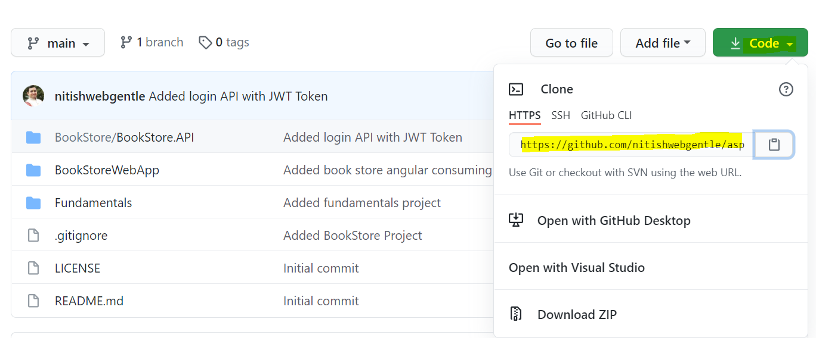

**2. Download the code directly**

You can also download the code as a zip file without installing anything.

Direct download link - <https://github.com/nitishwebgentle/asp-net-core-web-api/archive/refs/heads/main.zip>

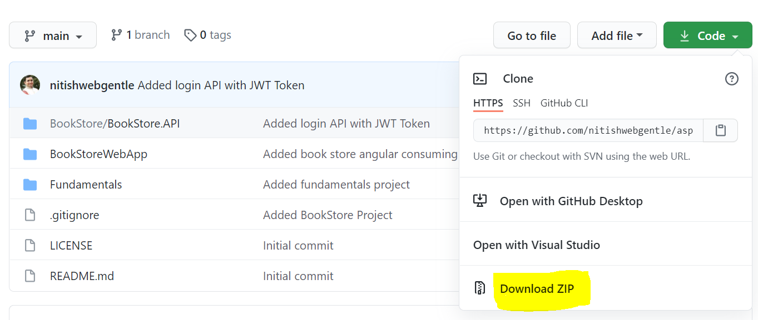

**Code structure:**

This repository has 3 different projects:

**1. Fundamentals**

At the root level in the Fundamentals folder there is a ConsoleToWebAPI project.

This project has all the fundamentals of the RESTful Web API.

**2. Book Store APIs**

At the root level in the BookStore/BookStore.API folder there is the real-world Book Store application.

This application has all the APIs about the Books.

**3. Angular Consuming application**

At the root level in the BookStoreWebApp folder there is an angular application.